**ACT**



Mata Praktikum : GOLANG INTERMEDIET

Kelas : 3IA20

Praktikum ke- : 5

Tanggal : 4 November 2022

Materi : (Data Binding)

NPM : 50420900

Nama : Muhammad Reza Hidayat

Ketua Asisten :

Nama Asisten :

Paraf Asisten :

Jumlah Lembar :



**LABORATORIUM TEKNIK INFORMATIKA**

**UNIVERSITAS GUNADARMA**

**2022**

1. LISTING PROGRAM

Database Command

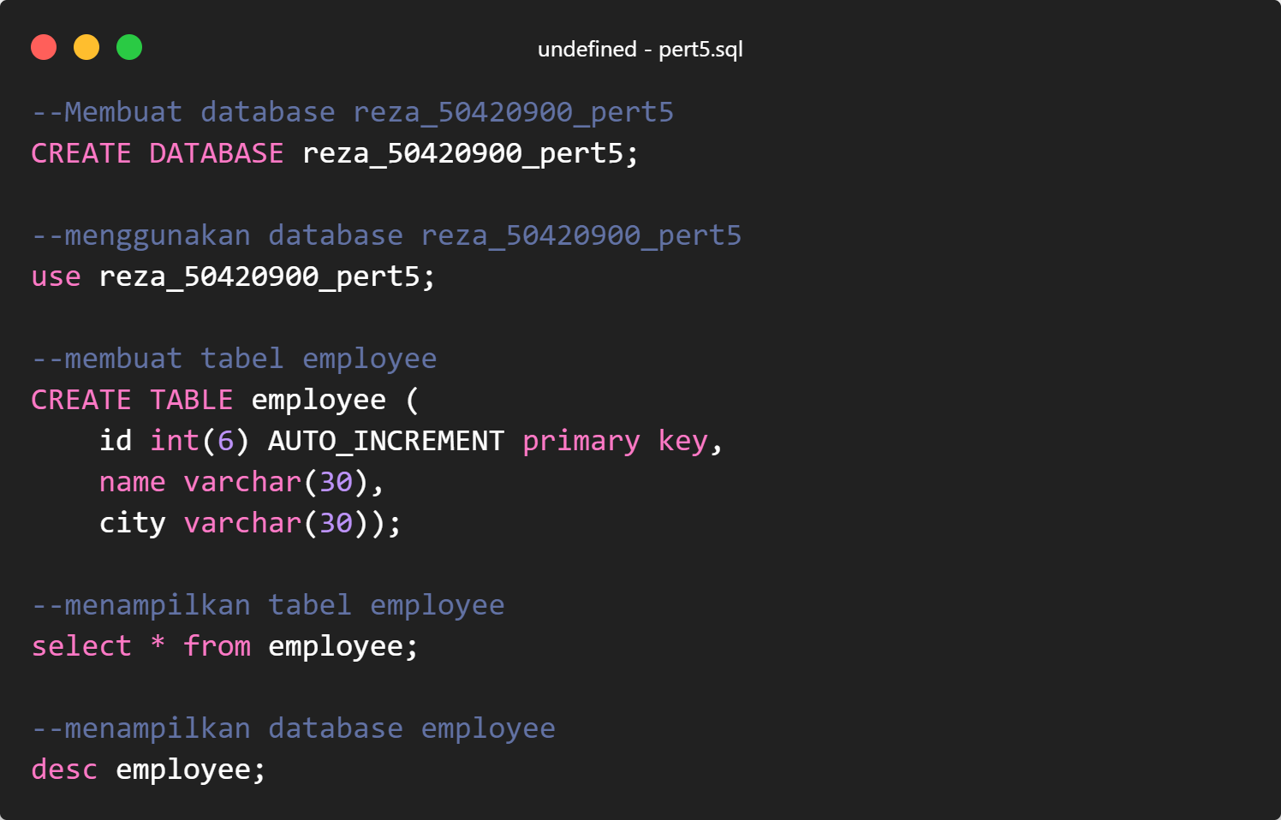

Struktur Folder

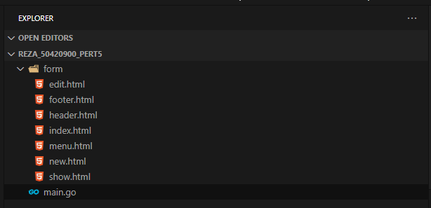

**edit.html**

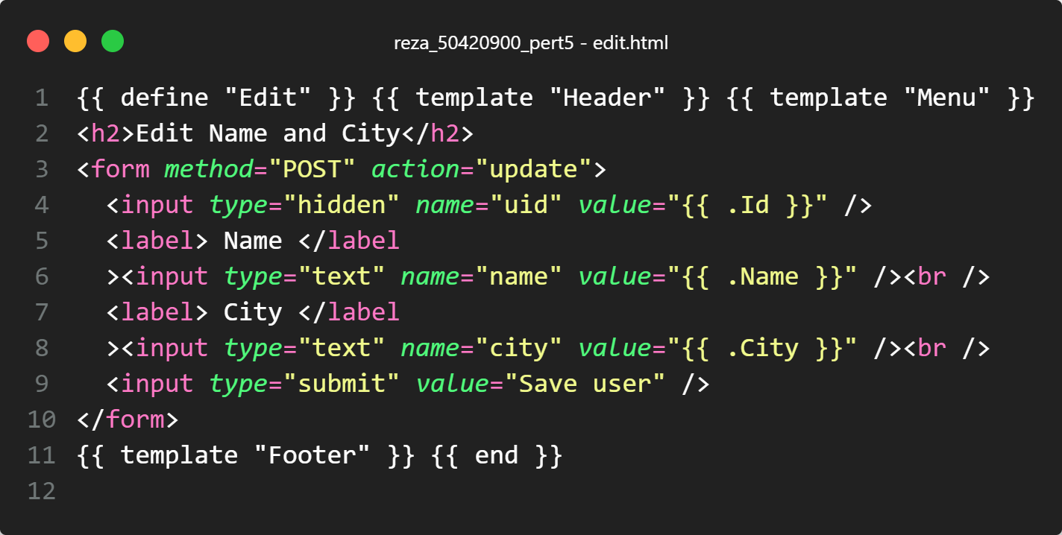

**footer.html**

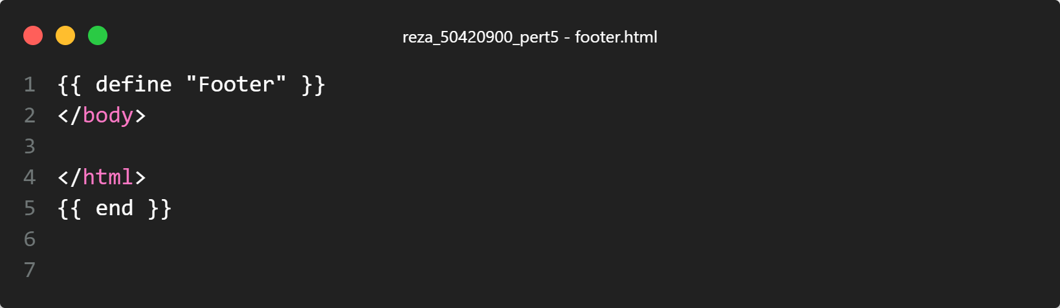

**header.html**

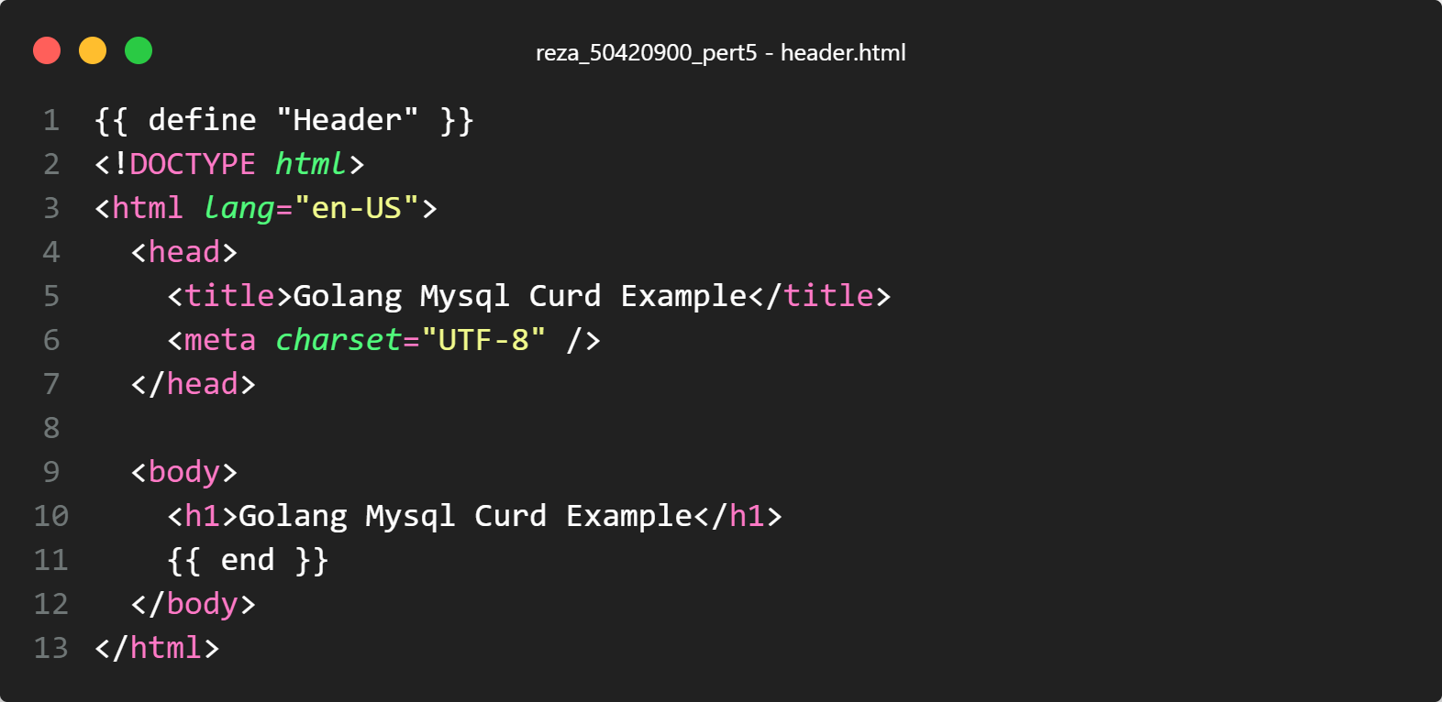

**index.html**

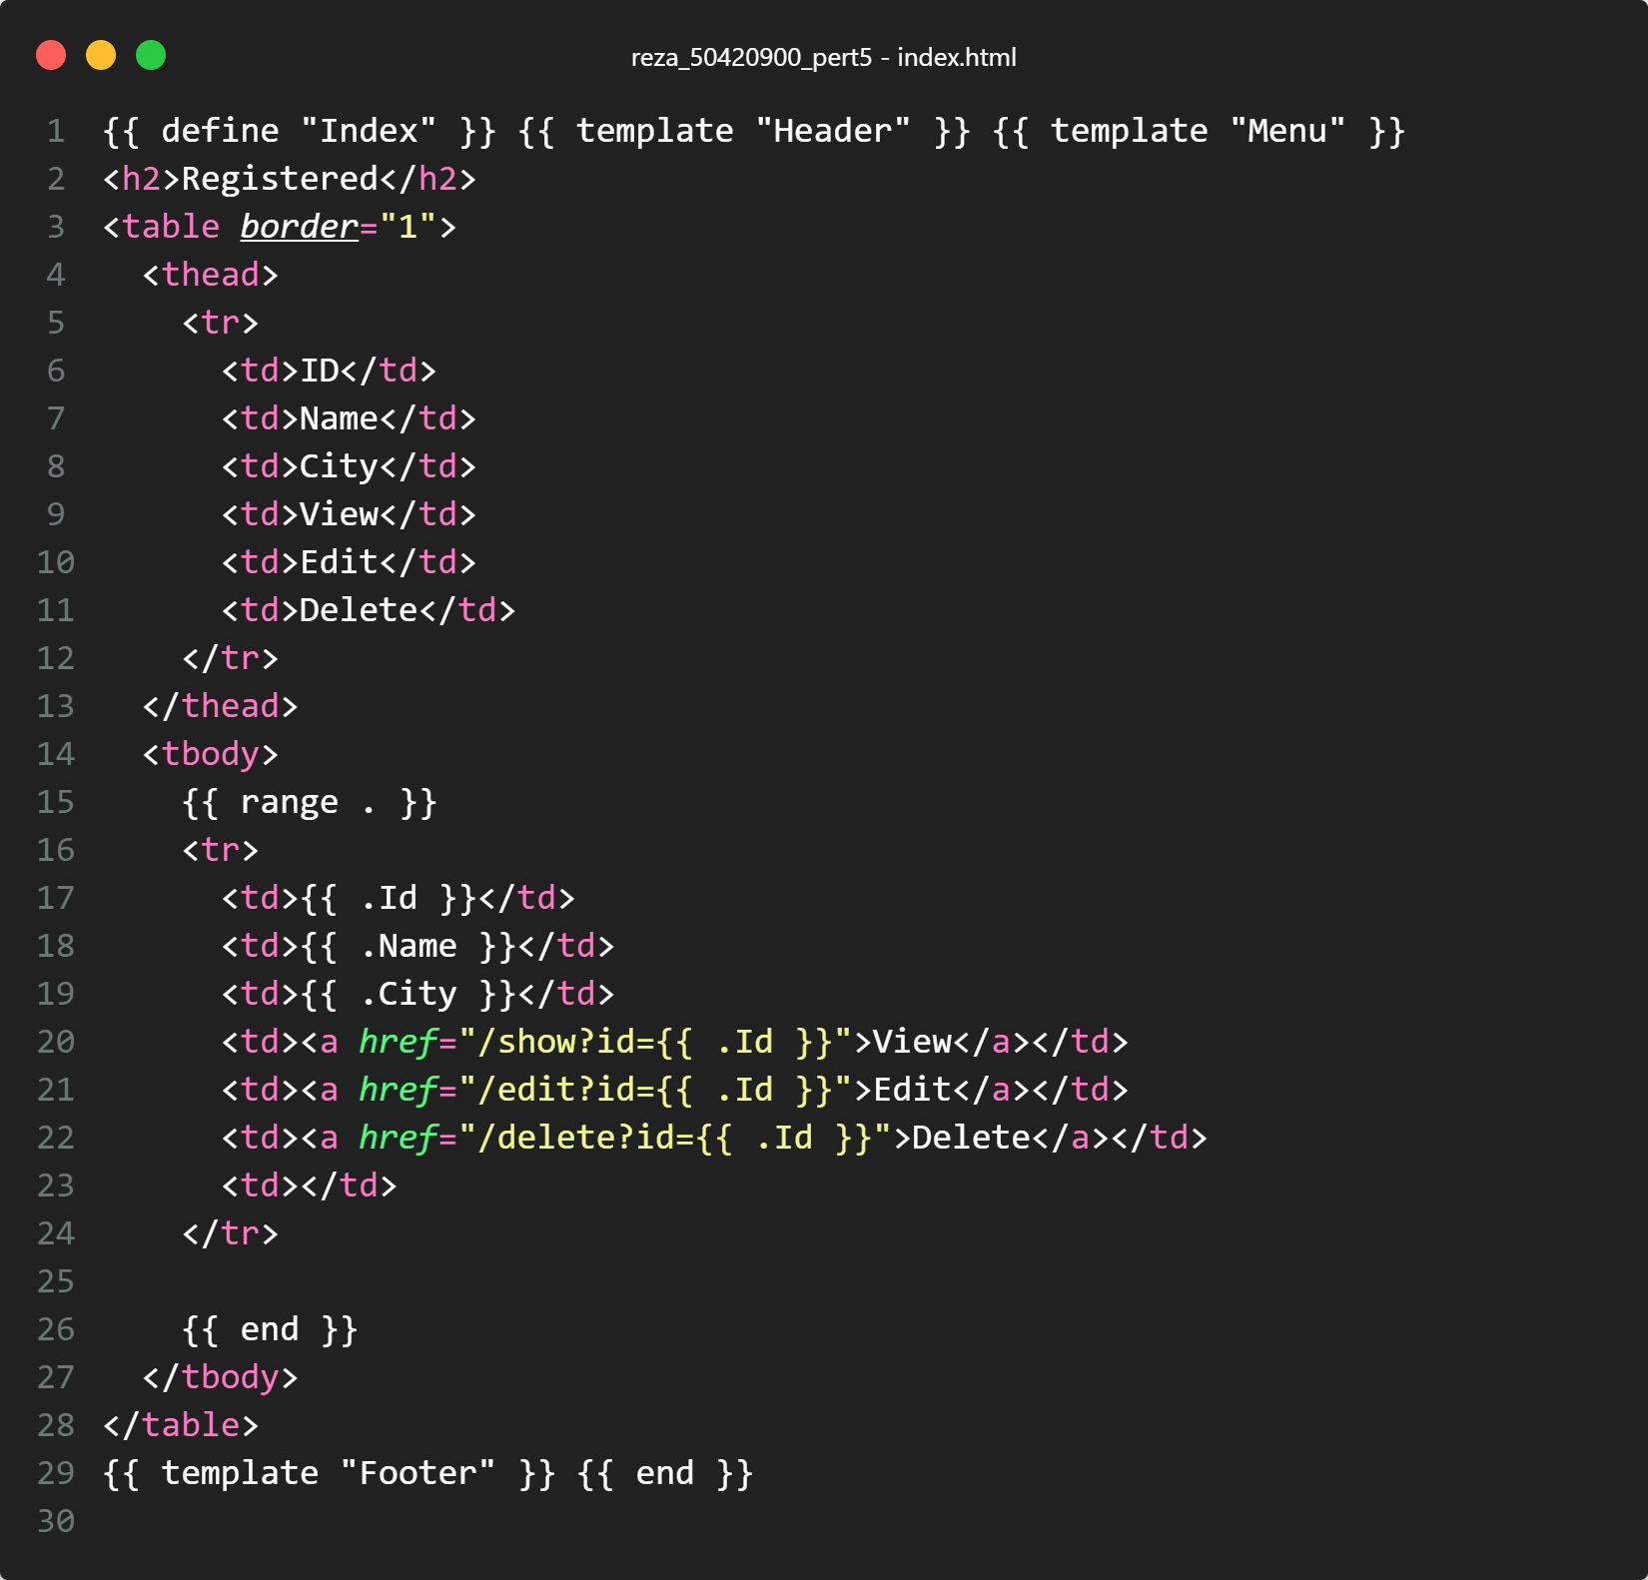

**menu.html**

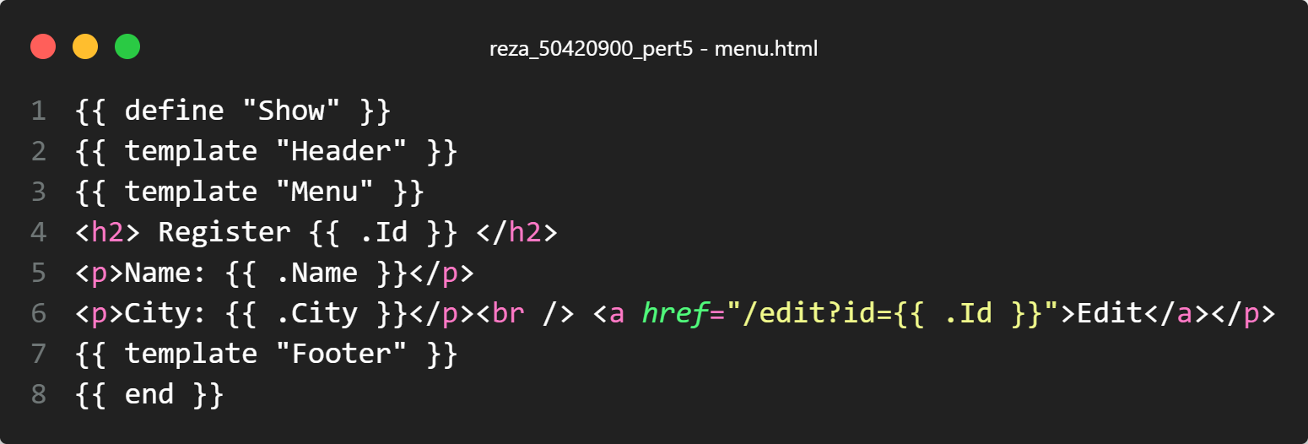

**new.html**

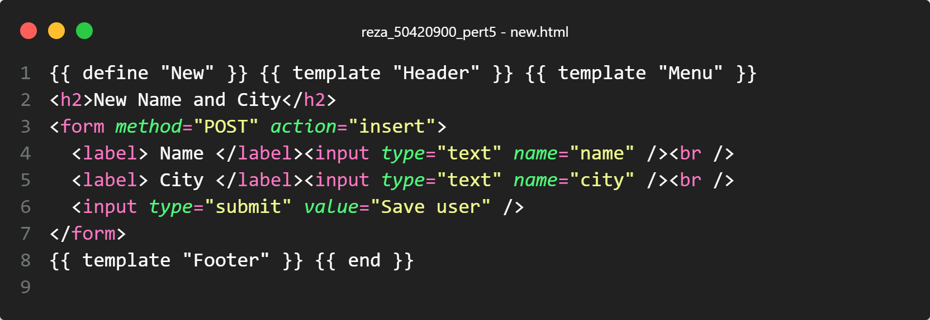

**show.html**

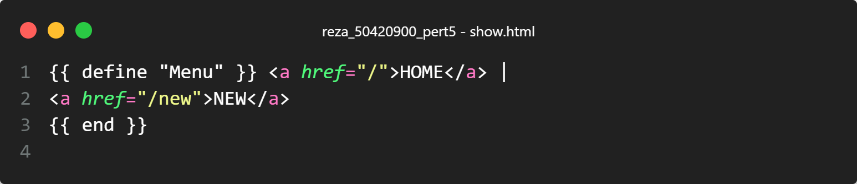

main.go

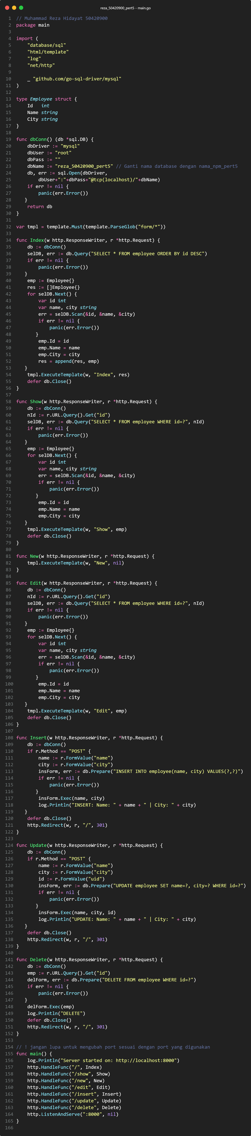

1. OUPUT PROGRAM

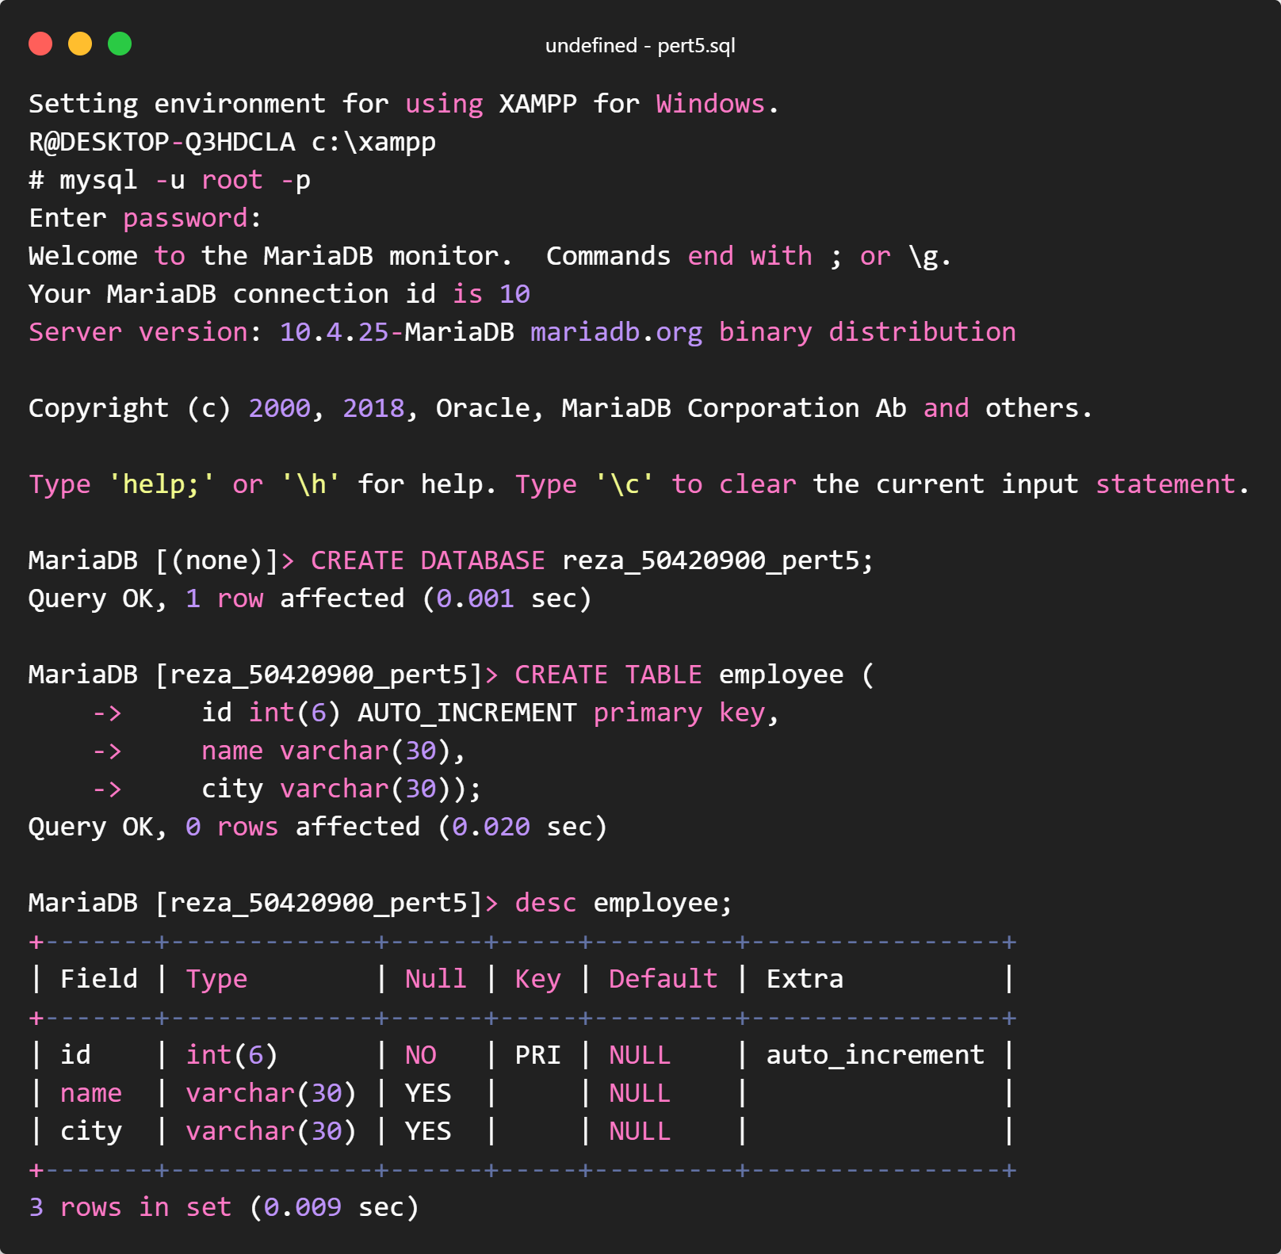

<http://localhost:8000/>

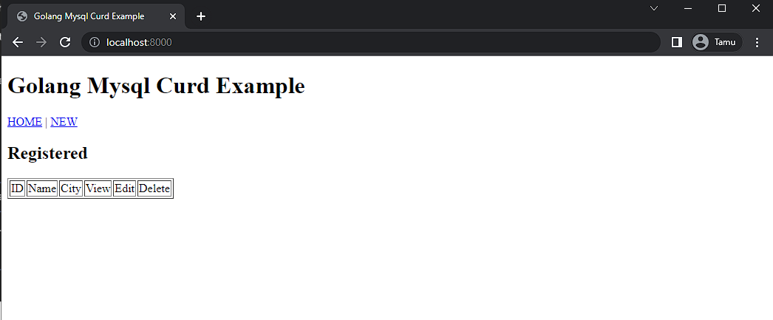

<http://localhost:8000/new>

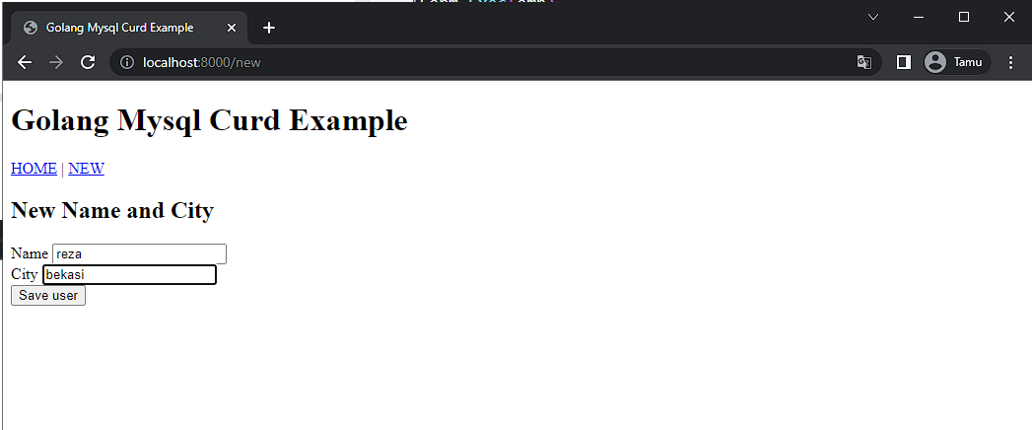

<http://localhost:8000/>

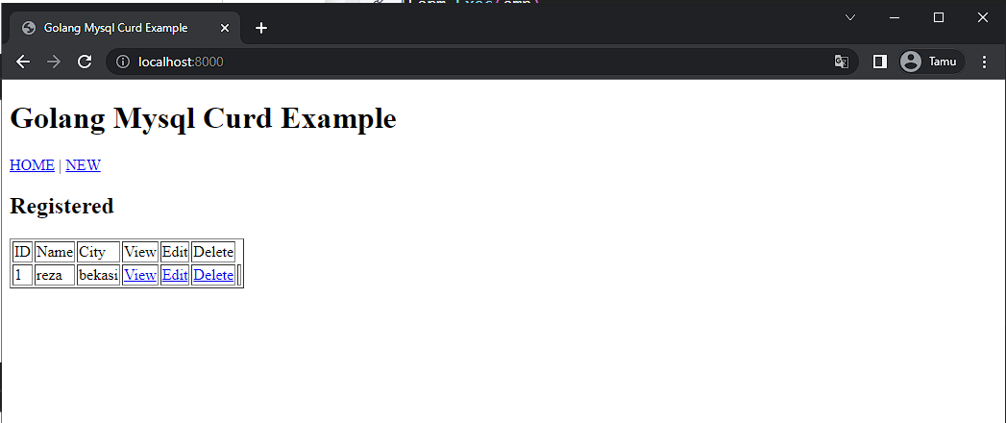

<http://localhost:8000/show?id=1>

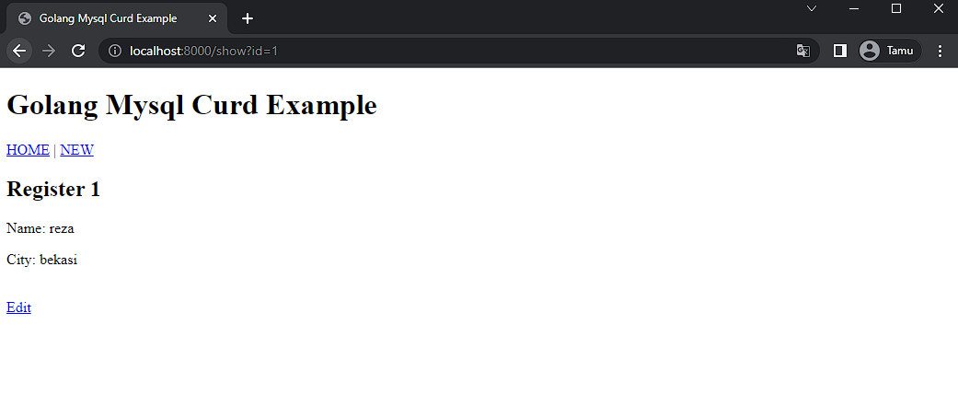

<http://localhost:8000/edit?id=1>

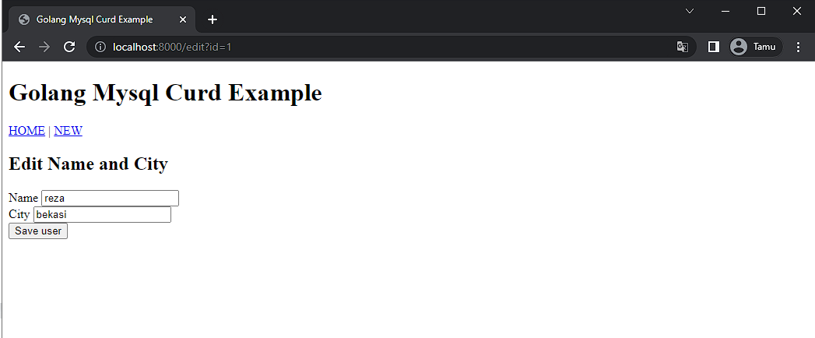

main.go

